**Project Design Phase-II**

**Technology Stack (Architecture & Stack)**

|  |  |
| --- | --- |
| Date | 15 October 2022 |
| Team ID | PNT2022TMID42291 |
| Project Name | Early Detection of Chronic Kidney Disease using Machine Learning |
| Maximum Marks | 4 Marks |

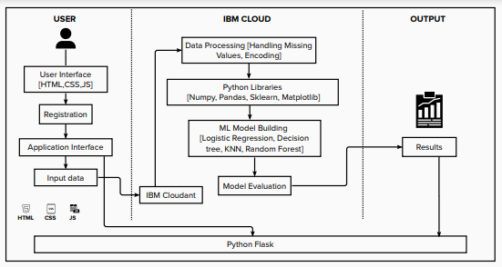

**Table-1: Components & Technologies:**

|  |  |  |  |
| --- | --- | --- | --- |
| **S.No** | **Component** | **Description** | **Technology** |
|  | User Interface | An Interface for the user to interact with the prediction model. | HTML, CSS, JavaScript |
|  | User Registration | User can register in the web application | HTML forms |
|  | Disease Prediction | The user enters the data which is given as input to model to predict the disease. | Machine Learning with Python. |
|  | Update Prediction result | The result of disease prediction is updated in the Web UI for the user to know the output. | Python. |
|  | Database | Relational database structure to store the user data | MYSQL. |
|  | Cloud Database | Database services on IBM cloud. | IBM Cloudant. |
|  | Machine Learning Model | To predict he chronic kidney disease (CKD) with various input parameters. | Random Forest, KNN, Decision tree, Logistic Registration. |
|  | Infrastructure (Server / Cloud) | Application Deployment on Cloud | IBM Cloud. |

**Table-2: Application Characteristics:**

| **S.No** | **Characteristics** | **Description** | **Technology** |
| --- | --- | --- | --- |
|  | Open-Source Frameworks | Python open-source frameworks are used to build web applications as well as to build Machine Learning models. | Python Flask, Numpy, Scikit-Learn, etc. |
|  | Scalable Architecture | The 3-tier architecture used with a separate user interface, application tier, and data tier makes it easily scalable. | IBM Watson Studio. |
|  | Availability | The web application is highly available as it is deployed in the cloud. | IBM Cloud. |
|  | Performance | The performance of the website is improved with caching and security. | IBM Cloud Internet Services. |